European Language Council / Conseil Européen pour les Langues
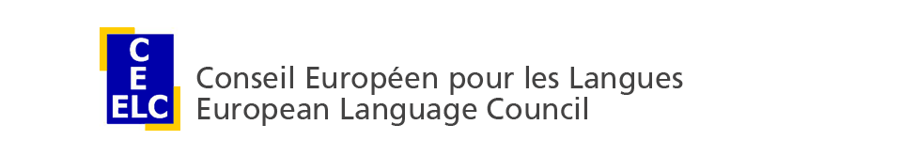

CEL/ELC Newsletter Issue 2, 2014

1. CEL/ELC Forum "Which language policy for Europe?”
Venue: Brussels, Katholieke Universiteit Leuven - Campus Brussels, Stormstraat/rue d’Assaut 2
Dates: 4-5 December 2014

Programme

Day 1, Thursday 4 December 2014
14.00 | Welcome and introduction: Maurizio Viezzi, CEL/ELC President
14.30 | Opening address: ‘Some Lessons from five Years EU Council Presidency’  Herman Van Rompuy, President of the European Council
15.00 | Keynote address: Frans Zwarts, University of Groningen
15.45 | Break
16.15 | Karen M. Lauridsen, Aarhus University, Chair of the CEL/ELC Task Force on Languages in the European Higher Education Area
16.35 | Sjur Bergan, Council of Europe
16.55 | François Grin, University of Geneva, coordinator of the MIME project
17.15 | Ion-Aurel Pop, Rector of Babeș-Bolyai University, Cluj-Napoca
17.35 | Pierre Mairesse, DG EAC, European Commission
17.55 | Discussion
18.30 | End of Day 1

Day 2, Friday 5 December 2014
10.30 | CEL/ELC Special Interest Group (SIG) on Languages and intercultural careers: Introduction by SIG coordinator Michael Kelly, University of Southampton, followed by one presentation and discussion
11.15 | CEL/ELC Special Interest Group (SIG) on Validation, recognition (and evaluation) of informal and non-formal language learning: Introduction by SIG co-coordinator Michael Hammersley, University of Bologna, followed by one presentation and discussion
12.00 | CEL/ELC Special Interest Group (SIG) on Multilingualism and Multiculturalism: Introduction by SIG coordinator Boris Vejdovsky, University of Lausanne, followed by one presentation and discussion
12.45 | Break
13.45 | CEL/ELC Special Interest Group (SIG) on Higher Education/University language policy: Introduction by SIG coordinators Manuel Célio Conceição, University of Algarve, and Jolanta Urbanikowa, University of Warsaw, followed by one presentation and discussion
14.30 | End of Day 2
The registration form is available on the CEL/ELC website (http://www.celelc.org/activities/Fora/Forum_2014/registration/index.html).

2. CEL/ELC Special Interest Groups (SIGs)
The Conseil Européen pour les Langues / European Language Council has launched four Special Interest Groups (SIGs):
· SIG 1: Languages and intercultural careers, coordinated by Michael Kelly
· SIG 2: Validation and recognition of informal and non-formal language learning, coordinated by Michael Hammersley and Maurizio Viezzi
· SIG 3: Multilingualism and multiculturalism, coordinated by Boris Vejdovsky
· SIG 4: Developing different models for language policies in Higher Education, coordinated by Manuel Célio Conceição and Jolanta Urbanikowa
The calls for expression of interest are available on the CEL/ELC website (http://www.celelc.org/activities/Working_groups/Active-Working-Groups/index.html). Colleagues interested in participating in the Special Interest Groups are invited to get in touch with the coordinators.

3. CEL/ELC General Assembly
The CEL/ELC General Assembly will be held in Brussels on 5 December 2014. Colleagues wishing to submit their candidature to the Board are invited to contact the CEL/ELC Secretariat. They will be invited to send in a 'statement of candidature'.

4. CEL/ELC membership
CEL/ELC membership is open to both institutions (active membership) and individuals (associate membership). The application form is available on the CEL/ELC website (http://www.celelc.org/about_us/members/Application/index.html). For information please get in touch with the CEL/ELC Secretariat.
-----------------------------------
Conseil Européen pour les Langues / European Language Council (CEL/ELC)
c/o Freie Universität Berlin :: ZE Sprachenzentrum
Habelschwerdter Allee 45 - 14195 Berlin, Germany
E-mail: secretariat-elc@sprachenzentrum.fu-berlin.de
http://www.celelc.org

